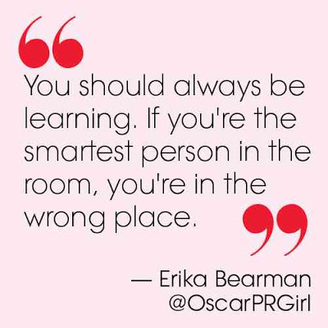

“You should always be learning. If you’re the smartest person in the room, you’re in the wrong place” –Erica Bearman.

I chose this quote because it really hits home for me. Like many, when I find myself in a group and I don’t understand all of the things being talked about, I feel very self conscious. Although I don’t like being in that situation, I know that in order for me to become better, I have to be around people that push me to get there. Even in this course, there have been plenty of times that I have seen terms that I didn’t have any idea what they were. I have found that when I am put in that situation it motivates me to find the answers to the questions that I have. I have felt fearful when thinking about getting my first web job, knowing that at first I will probably be the least experienced in the room. This quote helps me to remember that I have to continue to learn and get better and better and it takes an uncomfortable environment to do that.

http://sweetnothings04.blogspot.com/2013/03/a-little-wisdom-from-oscar-pr-girl.html